Polyhedral Boundary

Definition
# Source: AI Source: Provided by: [Data Path: Persons Table -> ID Column: 1, Name_En Column: Motasem Essam] -> From: [ChatGPT] on [7/25/2026]
A polyhedral boundary is a closed surface formed by a finite collection of flat polygonal faces joined along straight edges and meeting at vertices. It forms the outer boundary of a polyhedral solid, such as a cube, tetrahedron, prism, or pyramid.
Each face lies in a plane, adjacent faces meet along shared edges, and edges meet at vertices. For an ordinary closed polyhedron, these faces fit together to enclose a three-dimensional region without leaving gaps.
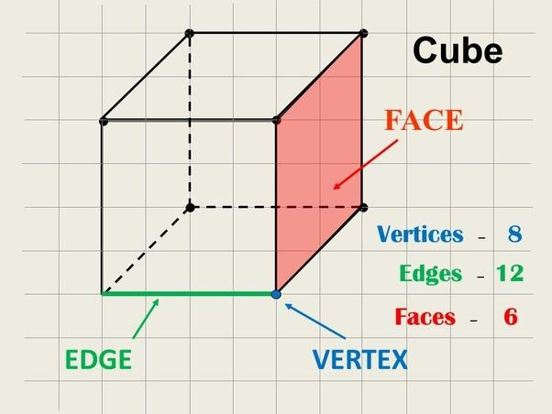
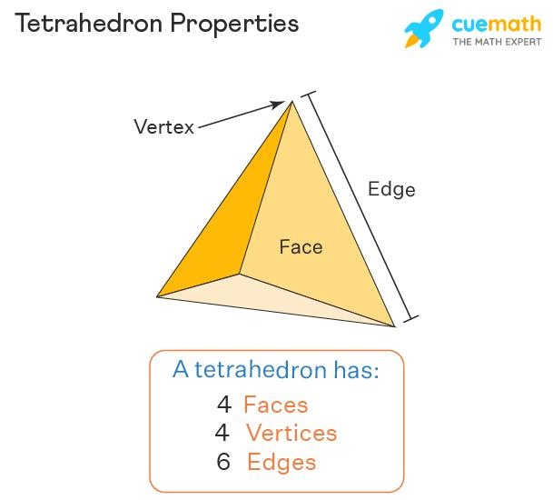
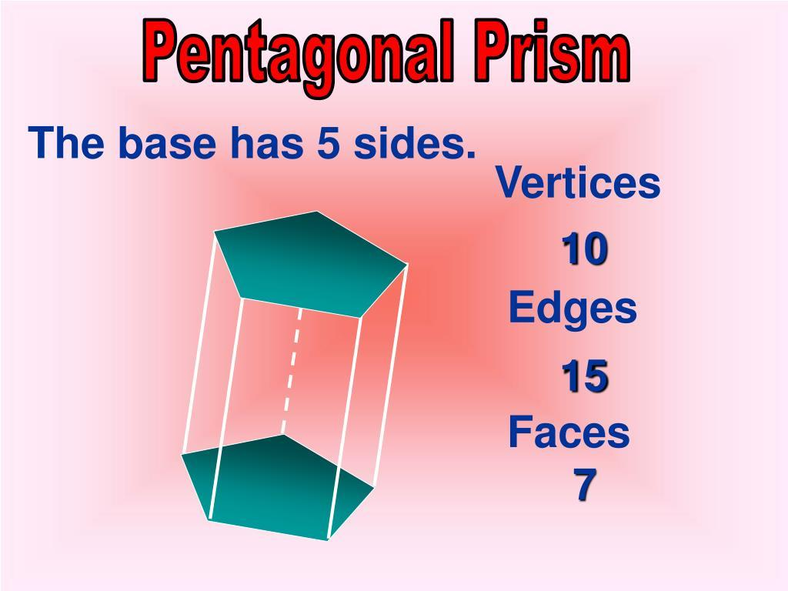

Simple Definition
# Source: AI Source: Provided by: [Data Path: Persons Table -> ID Column: 1, Name_En Column: Motasem Essam] -> From: [ChatGPT] on [7/25/2026]
A polyhedral boundary is the outer surface of a solid made entirely of flat polygonal faces.
For example:
- A cube has six square faces forming its polyhedral boundary.
- A tetrahedron has four triangular faces.
- A square pyramid has one square base and four triangular side faces.
- A prism has polygonal bases and rectangular or parallelogram-shaped side faces.
Unlike a spherical boundary, a polyhedral boundary consists of flat faces rather than one continuously curved surface.

Key Characteristics
# Source: AI Source: Provided by: [Data Path: Persons Table -> ID Column: 1, Name_En Column: Motasem Essam] -> From: [ChatGPT] on [7/25/2026]
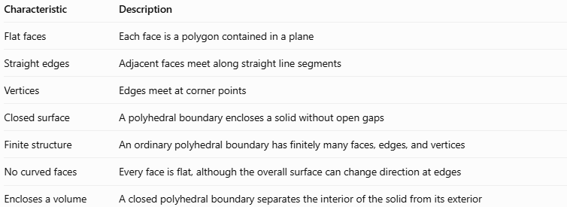
Characteristic | Description
Flat faces | Each face is a polygon contained in a plane
Straight edges | Adjacent faces meet along straight line segments
Vertices | Edges meet at corner points
Closed surface | A polyhedral boundary encloses a solid without open gaps
Finite structure | An ordinary polyhedral boundary has finitely many faces, edges, and vertices
No curved faces | Every face is flat, although the overall surface can change direction at edges
Encloses a volume | A closed polyhedral boundary separates the interior of the solid from its exterior

Geometric Representation
# Source: AI Source: Provided by: [Data Path: Persons Table -> ID Column: 1, Name_En Column: Motasem Essam] -> From: [ChatGPT] on [7/25/2026]
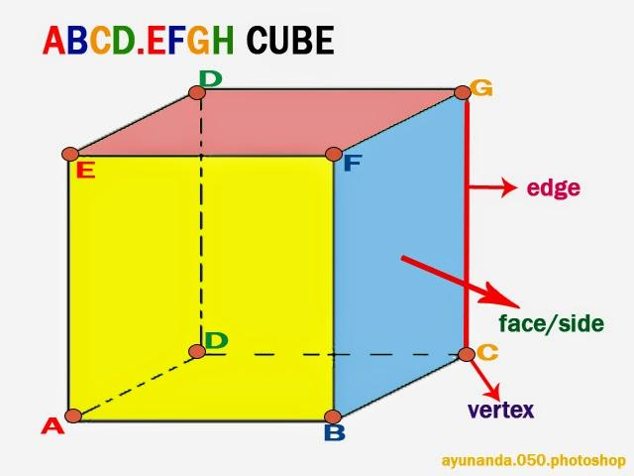
A polyhedral boundary is constructed from polygonal faces. These faces connect along edges, and the edges meet at vertices.

Face
# Source: AI Source: Provided by: [Data Path: Persons Table -> ID Column: 1, Name_En Column: Motasem Essam] -> From: [ChatGPT] on [7/25/2026]
A flat polygon that forms part of the boundary. For a cube, every face is a square.
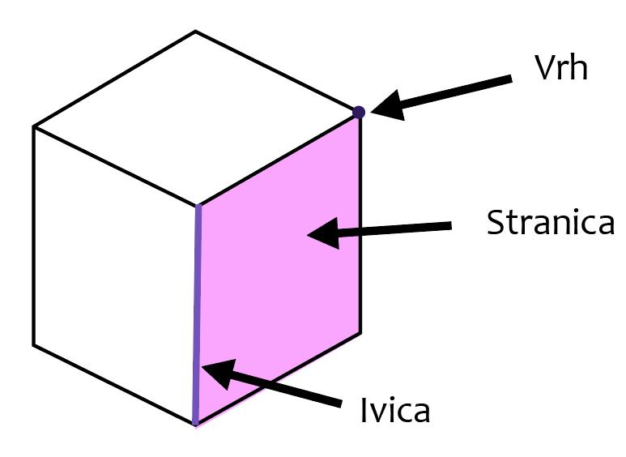

Edge
# Source: AI Source: Provided by: [Data Path: Persons Table -> ID Column: 1, Name_En Column: Motasem Essam] -> From: [ChatGPT] on [7/25/2026]
A straight segment where two adjacent faces meet.
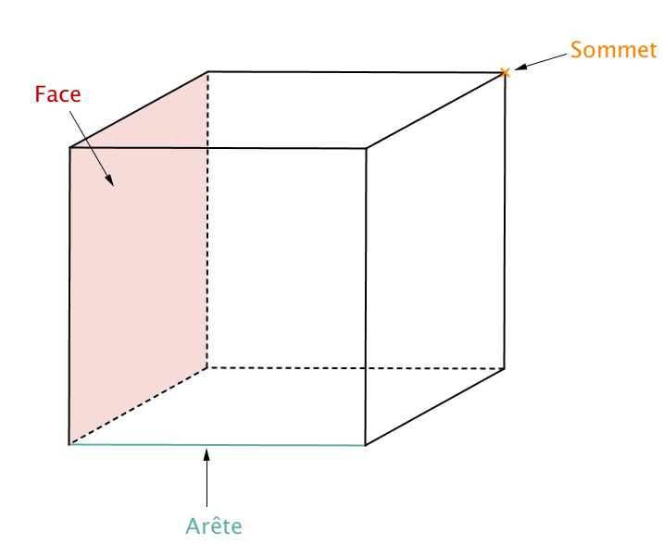

Vertex
# Source: AI Source: Provided by: [Data Path: Persons Table -> ID Column: 1, Name_En Column: Motasem Essam] -> From: [ChatGPT] on [7/25/2026]
A corner point where the edges meet.
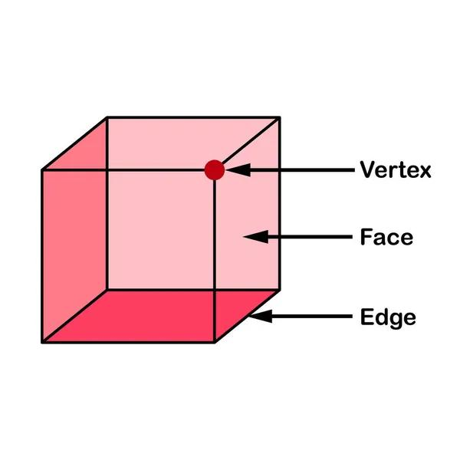

Mathematical Representation

Polyhedral boundary as a union of faces
# Source: AI Source: Provided by: [Data Path: Persons Table -> ID Column: 1, Name_En Column: Motasem Essam] -> From: [ChatGPT] on [7/25/2026]
If a polyhedron has polygonal faces $F_{1},F_{2},…,F_{n}$, its boundary can be represented as
$$∂P=\bigcup_{i=1}^{n}{F_{i}}$$
Here:
- $P$ represents the solid.
- $∂P$ represents its boundary.
- $F_{i}$ represents one polygonal face.
- $n$ is the finite number of faces.
The union of all faces forms the complete outer surface.

Number of faces, edges, and vertices
# Source: AI Source: Provided by: [Data Path: Persons Table -> ID Column: 1, Name_En Column: Motasem Essam] -> From: [ChatGPT] on [7/25/2026]
For a convex polyhedron, Euler's formula states
$$V-E+F=2$$
where:
- $V$ is the number of vertices.
- $E$ is the number of edges.
- $F$ is the number of faces.
For a cube,
$$V=8, E=12, F=6$$
Substituting into Euler's formula gives
$$8-12+6=2$$
Therefore, the cube satisfies Euler's formula.

Surface area
# Source: AI Source: Provided by: [Data Path: Persons Table -> ID Column: 1, Name_En Column: Motasem Essam] -> From: [ChatGPT] on [7/25/2026]
The total surface area of a polyhedral boundary is the sum of the areas of all its polygonal faces:
$$A_{\text{total}}=\sum_{i=1}^{n}{A}\left(F_{i}\right)$$
For a cube with side length $s$,
$$A_{\text{total}}=6s^{2}$$
For example, if $s=3$ units,
$$A_{\text{total}}=6\left(3^{2}\right)=54$$
square units.

Volume enclosed by a polyhedral boundary
# Source: AI Source: Provided by: [Data Path: Persons Table -> ID Column: 1, Name_En Column: Motasem Essam] -> From: [ChatGPT] on [7/25/2026]
The volume depends on the shape of the enclosed solid.
For a cube,
$$V=s^{3}$$
For a prism,
$$V=A_{\text{base}}h$$
For a pyramid,
$$V=\frac{1}{3}A_{\text{base}}h$$
The boundary determines the shape of the enclosed solid, while the appropriate volume formula depends on that solid's geometry.

Worked Examples
# Source: AI Source: Provided by: [Data Path: Persons Table -> ID Column: 1, Name_En Column: Motasem Essam] -> From: [ChatGPT] on [7/25/2026]
Example 1: Identify the polyhedral boundary of a cube
A cube has six square faces.
Solution:
Each square is a flat polygon, and neighboring squares meet along straight edges. Together, the six faces form a closed surface.
The cube has:
- $6$ faces
- $12$ edges
- $8$ vertices
Therefore, its outer surface is a polyhedral boundary.
Example 2: Verify Euler's formula for a tetrahedron
A tetrahedron has four triangular faces, six edges, and four vertices.
Solution:
Using Euler's formula,
$$V-E+F=2$$
Substitute the values:
$$4-6+4=2$$
The formula holds, so the tetrahedron's structure satisfies Euler's formula for convex polyhedra.
Example 3: Calculate the surface area of a cube
A cube has side length $5$ cm. Find the area of its polyhedral boundary.
Solution:
The cube has six square faces, each with area
$$A_{\text{face}}=5^{2}=25{\text{ cm}}^{2}$$
Therefore,
$$A_{\text{total}}=6\left(25\right)=150{\text{ cm}}^{2}$$
The total area of the polyhedral boundary is $150{\text{ cm}}^{2}$.
Example 4: Distinguish a polyhedral boundary from a curved boundary
Consider a cube and a sphere.
Solution:
- The cube's boundary consists entirely of flat square faces connected by straight edges.
- The sphere's boundary is a smooth curved surface and does not consist of polygonal faces.
Therefore, the cube has a polyhedral boundary, while the sphere has a curved boundary.

Comparison With Related Concepts
# Source: AI Source: Provided by: [Data Path: Persons Table -> ID Column: 1, Name_En Column: Motasem Essam] -> From: [ChatGPT] on [7/25/2026]
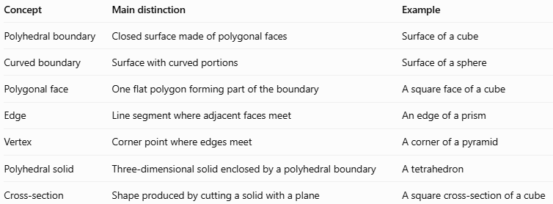
Concept | Main distinction | Example
Polyhedral boundary | Closed surface made of polygonal faces | Surface of a cube
Curved boundary | Surface with curved portions | Surface of a sphere
Polygonal face | One flat polygon forming part of the boundary | A square face of a cube
Edge | Line segment where adjacent faces meet | An edge of a prism
Vertex | Corner point where edges meet | A corner of a pyramid
Polyhedral solid | Three-dimensional solid enclosed by a polyhedral boundary | A tetrahedron
Cross-section | Shape produced by cutting a solid with a plane | A square cross-section of a cube

Applications
# Source: AI Source: Provided by: [Data Path: Persons Table -> ID Column: 1, Name_En Column: Motasem Essam] -> From: [ChatGPT] on [7/25/2026]
- Architecture: Modeling the faces and edges of buildings and structural components.
- Engineering: Describing the outer surfaces of mechanical parts.
- Computer graphics: Representing 3D objects using polygon meshes.
- 3D printing: Constructing digital models from connected polygonal faces.
- Geometry: Calculating surface area, volume, and relationships between faces, edges, and vertices.
- Manufacturing: Designing objects with flat surfaces, such as boxes, prisms, and machine components.

Key Points
# Source: AI Source: Provided by: [Data Path: Persons Table -> ID Column: 1, Name_En Column: Motasem Essam] -> From: [ChatGPT] on [7/25/2026]
- A polyhedral boundary is a closed surface made of flat polygonal faces.
- Its main elements are faces, edges, and vertices.
- A cube, tetrahedron, prism, and pyramid are examples of polyhedral solids.
- The total surface area is the sum of the areas of the faces.
- For convex polyhedra, Euler's formula is $V-E+F=2$.
- A polyhedral boundary differs from a curved boundary because all its faces are planar polygons.

Conclusion
# Source: AI Source: Provided by: [Data Path: Persons Table -> ID Column: 1, Name_En Column: Motasem Essam] -> From: [ChatGPT] on [7/25/2026]
A polyhedral boundary in solid geometry is the outer surface of a polyhedral solid, formed by connected flat polygonal faces. Its faces, edges, and vertices define the structure of the solid and provide the basis for calculating surface area and studying spatial relationships.

